
Bachelor of Computer Applications

Semester – V

Business Analytics

Experiment No.: 4

Title: Data Cleaning using Power Query

GitHub Link - https://github.com/DakshrajKurki/Assignment-Business-analytics

Submitted By: Dakshraj Singh Chandawat
Reg. No.: 2411021240050
Date: 09/09/2026

Submitted To:
Faculty Name: Mr. Aman Kumar Sharma

Department of Computer Application
Alliance University
Chandapura - Anekal Main Road, Anekal
Bengaluru – 562106

Experiment No.: 4
Data Cleaning using Power Query
Problem Statement
You are a Data Analyst in a company. The company has received customer sales data that is not ready for analysis — it contains missing values, duplicate records, and inconsistent entries across several fields. The task is to clean and prepare this dataset using Power Query in Power BI, correcting data quality issues before any analysis is performed, and to then build an interactive Power BI dashboard so that management can view business performance from the cleaned data.
Methodology / Steps Followed
Step 1: Data Collection
- Obtained a transactional sales dataset (dirty_cafe_sales) containing customer purchase records.
- The dataset included the fields Transaction ID, Item, Quantity, Price Per Unit, Total Spent, Payment Method, Location, and Transaction Date.
- The raw file was known to contain data quality issues, including missing values, invalid entries, and inconsistent category labels.
Step 2: Data Import
- Opened Power BI Desktop and used the Get Data option to import the dataset.
- Loaded the file into Power Query Editor for inspection and cleaning.
- Used the Column Quality and Column Distribution indicators to assess the raw data. Before cleaning, the Payment Method and Location columns showed a large proportion of empty values, while the Total Spent and Transaction Date columns contained invalid text entries such as "ERROR" and "UNKNOWN" in place of valid values.
Step 3: Data Cleaning and Transformation
- Promoted the first row as column headers and set the correct data type for each column.
- Replaced inconsistent and placeholder values (such as "ERROR", "UNKNOWN", and blank cells) across the Item, Payment Method, and Location columns with a standardized label, so that every column had a consistent, valid set of categories.
- Trimmed and cleaned all text columns to remove extra spaces and hidden characters (Trimmed Text, Cleaned Text).
- Filtered out rows containing unusable or unrecoverable data (Filtered Rows).
- Added a calculated custom column to recompute Total Spent as Quantity × Price Per Unit, correcting the records where the original Total Spent value was invalid.
- Removed the original faulty Total Spent column and renamed the newly calculated column back to "Total Spent", so the final table kept clean, business-friendly column names.
- After cleaning, the Column Quality indicators confirmed 100% valid, 0% error, and 0% empty values across all key columns, and the Transaction ID column confirmed there were no duplicate records (1000 distinct and 1000 unique values).
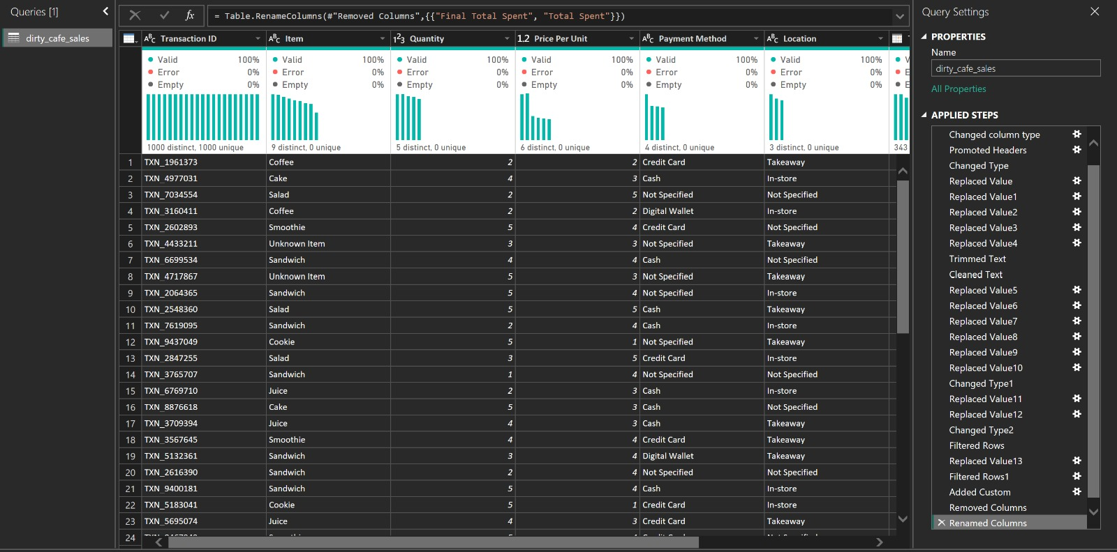
Figure 1: Cleaned dirty_cafe_sales table in Power Query, showing 100% valid, 0% error, and 0% empty values across columns after cleaning.
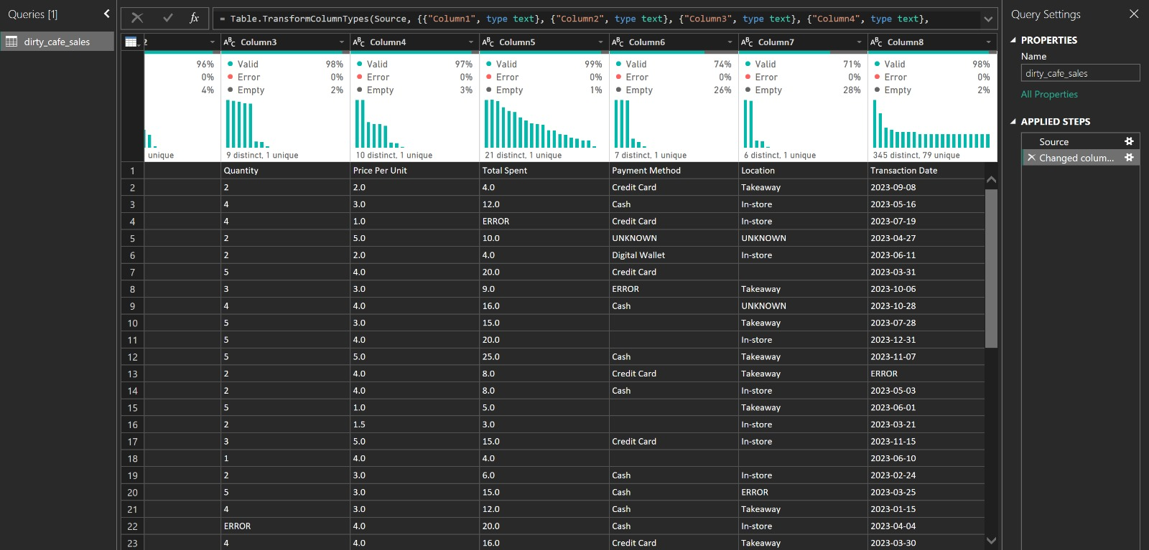
Figure 2: Raw dataset before cleaning, showing missing values in Payment Method and Location, and "ERROR"/"UNKNOWN" entries in Total Spent, Payment Method, and Transaction Date.
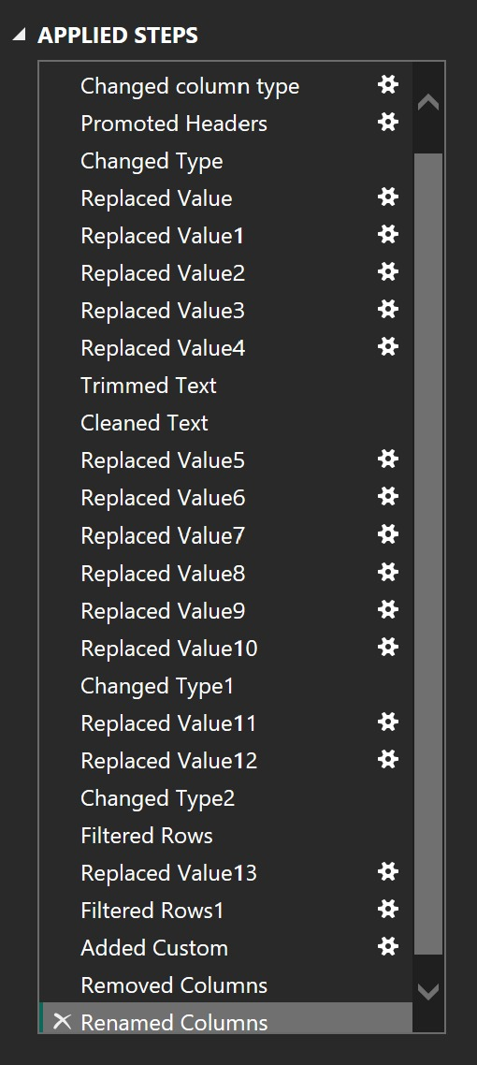
Figure 3: Complete list of Applied Steps used in Power Query to clean and transform the dataset.
Step 4: Loading the Cleaned Data
- Closed and applied the query, loading the cleaned dirty_cafe_sales table into the Power BI data model.
- Verified that the loaded table was free of duplicate, missing, and inconsistent values, and ready to be used for reporting.
Step 5: Dashboard Development
- Created KPI cards for Total Sales, Total Transactions, and Average Order Value.
- Developed charts for Sales by Item and Sales by Payment Method.
- Added a chart for Location-wise sales performance (In-store vs. Takeaway).
- Added slicers for Item, Payment Method, and Transaction Date to make the dashboard interactive.
- Designed a single-page interactive business dashboard summarizing overall sales performance.
Output
[Insert final Power BI dashboard screenshot here]
The final Power BI dashboard, built on the cleaned dataset, provides:
- Total Sales and Total Transactions Overview
- Item-wise Sales Analysis
- Payment Method Distribution
- Location-wise Sales Performance
- Interactive Filters and Slicers
The dashboard enables management to monitor sales performance on clean, reliable data and make data-driven decisions effectively.
Conclusion
This experiment focused on cleaning and preparing a real-world style dataset containing missing values, duplicate records, and inconsistent entries using Power Query in Power BI. By systematically replacing invalid and placeholder values, standardizing text, correcting a faulty calculated field, and removing unusable rows, a clean and reliable dataset was produced. This cleaned dataset was then used as the foundation for an interactive Power BI dashboard, giving a centralized and accurate view of sales performance to support business reporting and decision-making.
Learning Outcomes
Through this project, I learned:
- How to identify data quality issues using the Column Quality and Column Distribution tools in Power Query.
- Techniques for replacing invalid, missing, and inconsistent values in a dataset.
- How to use calculated/custom columns in Power Query to correct erroneous data.
- Trimming and cleaning text data for consistency across categorical columns.
- Filtering out unusable records as part of a data cleaning workflow.
- Designing and building an interactive Power BI dashboard from a cleaned dataset.

